 VINOD SIR’S GROUP TUTION

MATHS-I-PRACTICE PAPER

1. For the equations with variables x and y, if Dx = 26, Dy = −39 and D = 13 then x =?
2. If 49 x – 57 y = 172 and 57 x – 49 y = 252 then x + y =?
3. Decide whether (0, 2) is the solution of the equation 5x + 3y = 6
4. 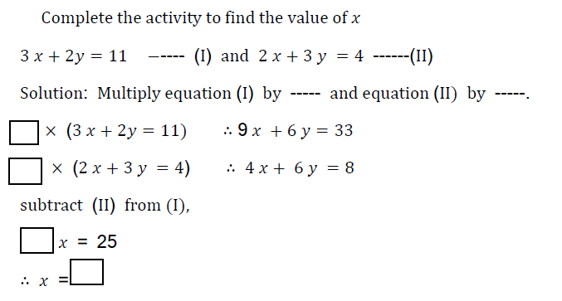
5. Complete the following activity to solve the given quadratic equation by factorization method.
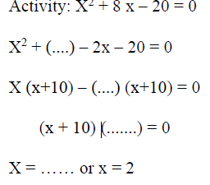
6. Kalpana saves some amount every month. In first three months she saves Rs.100, Rs.150 and Rs.200 respectively. In how many months will she save Rs.1200?
7. Find t21, if S41 = 4510 in an A.P.
8. The faces of a die bear numbers 0, 1, 2, 3, 4, 5. If the die is rolled twice, then find the probability that the product of digits on the upper face is zero.
9. Find the number of shares received when ` 60,000 was invested in the shares of FV ` 100 and MV ` 120.
10. The marks obtained by a student in different subjects are shown. Draw a pie diagram showing the information.

